**Project Development Phase Delivery of Sprint-1**

|  |  |
| --- | --- |
| Team ID | PNT2022TMID31937 |
| Project Name | Retail Store Stock Inventory Analytics |

**Project Development Phase: Sprint-1:**

* Data Collection
* Data Preparation

**Uploading the data:**

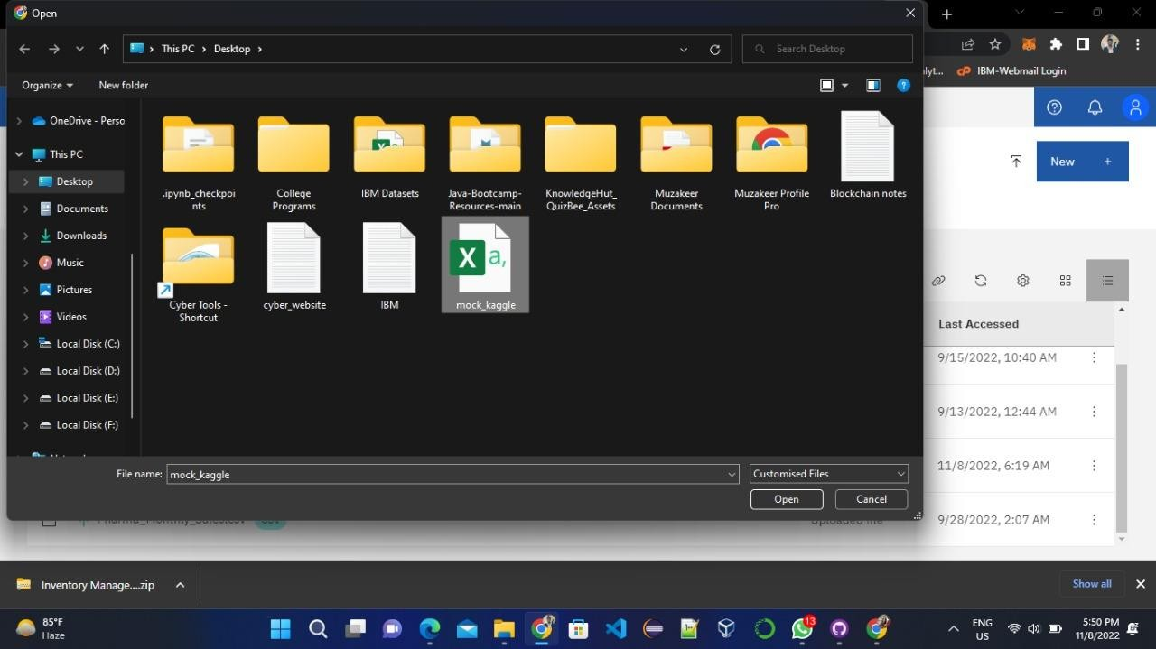

**Creating data module**

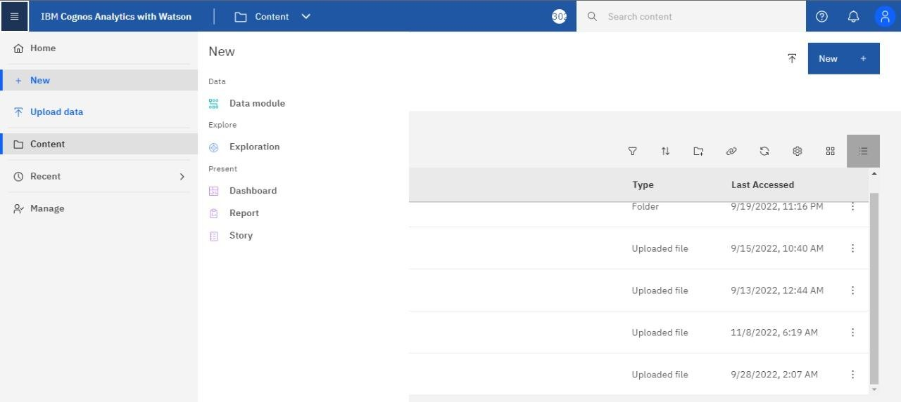

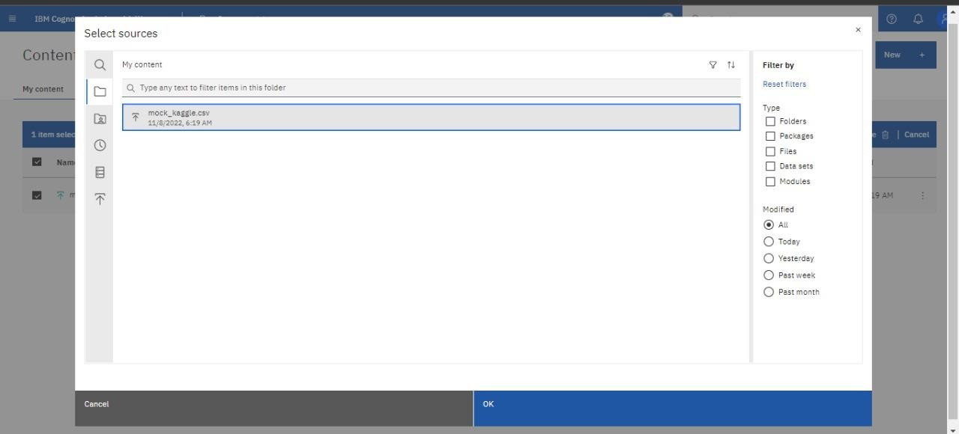

**Creating expressions:**

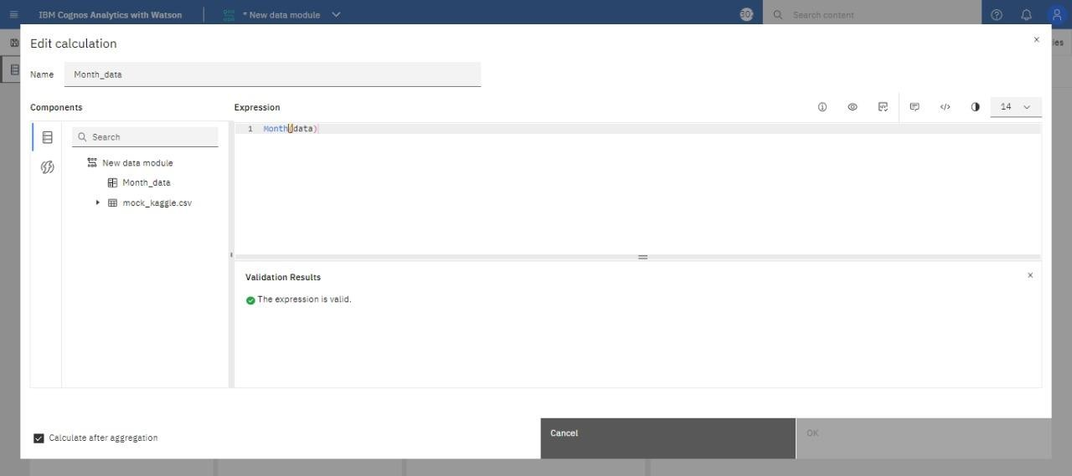

**Month Data:**

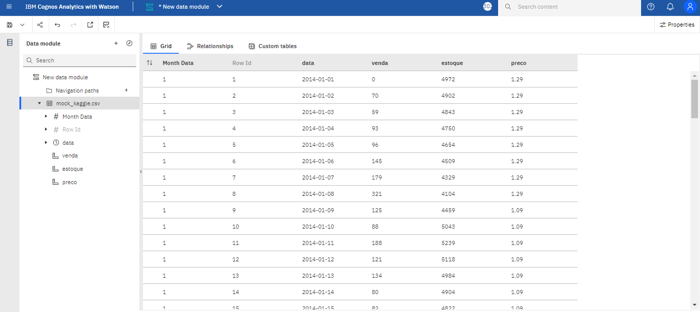

**Sales wise:**

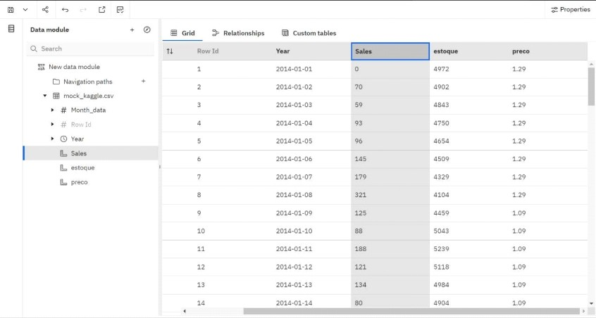

**Stock wise:**

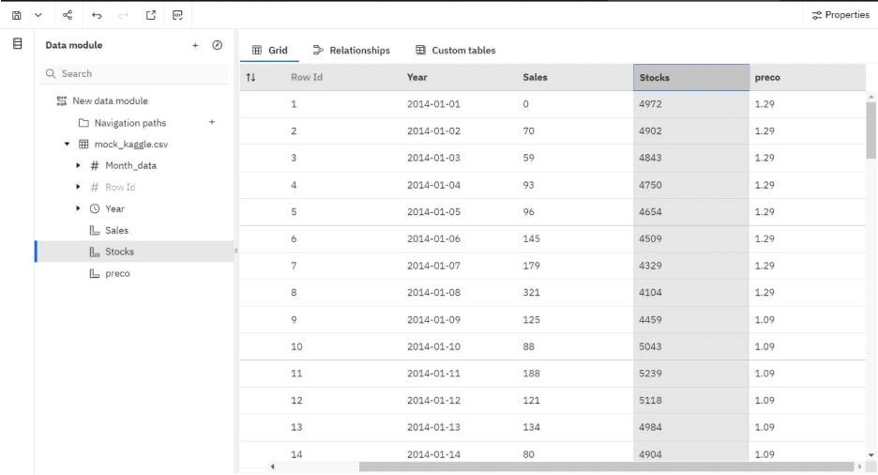

**Pricewise:**

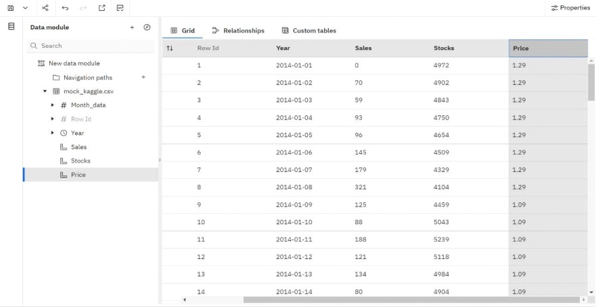

**Year format data:**

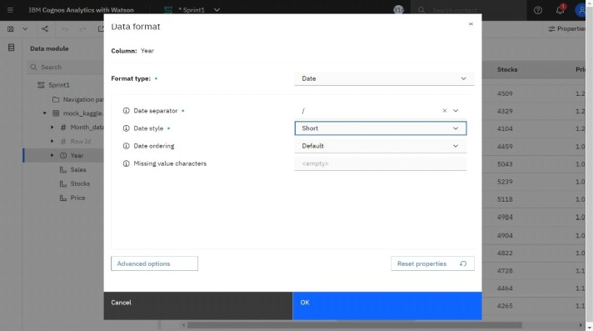

**Cognos Link:**

https://us1.ca.analytics.ibm.com/bi/?perspective=ca modeller&pathRef=.my_folders%2FSprint-1%2FSprint1